Using Your Own Custom Dialog Box
Published by Mike Hernandez
and shared with the Seattle Access Group.
One of the questions I’m asked most frequently concerns gathering input from the user to use as criteria for a query or report. There are a number of circumstances under which you’d want to ask the user for a set of dates, a company name, or for the name of some specific item. Their input would then make the information provided by the query or report more meaningful and useful. Of course, the simplest answer to this question is to use a Parameter Query for the task. However, several problems arise when you use this type of query.
The first is that you can’t display all of the parameters simultaneously. When you create and use a Parameter Query, Access provides a dialog box for each parameter in the query displays each one in sequence when you run the query. There’s no way for you to move to a previous dialog box should you realize that you’ve entered an incorrect or invalid value.
The second problem is that you can’t assign a combo box to any parameter dialog box provided by Access. As you know, using a combo box is an effective way to ensure that the user enters a valid value.
Finally, there’s no way to totally validate the data. While you can validate the datatype to some extent, there’s no way to ensure that the values entered by the user are truly valid. Writing and using a VBA procedure is the only real way of providing this type of data integrity.
So what is the answer? Use your own custom dialog box! You’ll just create a form that has the look and feel of a dialog box to gather the input you need from the user. When the user presses the "OK" button, an Event Procedure will open a query, form or report based on the values provided by the user.
Let’s use the tried and true Customer Orders example to illustrate how this technique works. (Please note that this technique can be used on any type of database.) For this example, you’ll need the following objects:

tblCustomer | This table contains names, addresses, etc., of each customer.
tblOrder | This table contains general information of all customer orders.
qryCustomerOrdersByDate | This query shows the customer name, city, order numbers and order dates.
qcboCustomerCityList | This query supplies a list of cities drawn from the tblCustomers table.
fdlgAskForDatesAndCity | This form allows the user to enter a range of dates and select a city.

Here are the structures for tblCustomer and tblOrder table.
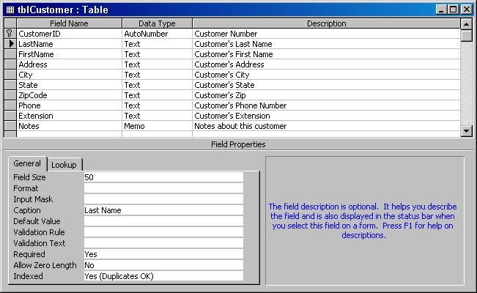

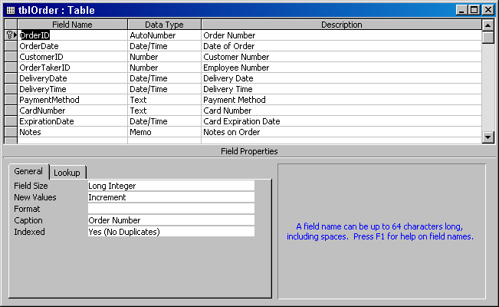

After you’ve created the tables, set up a relationship between them in the Relationships Window and then add some data into them. You’ll need the data in order to test this technique.

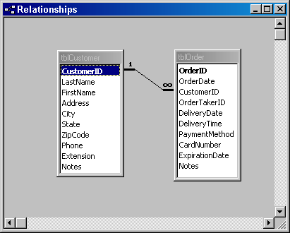

Now create the qcboCustomerCityList. Note that the Unique Values property of the query has been set to "Yes". This will ensure that the query displays unique city names.

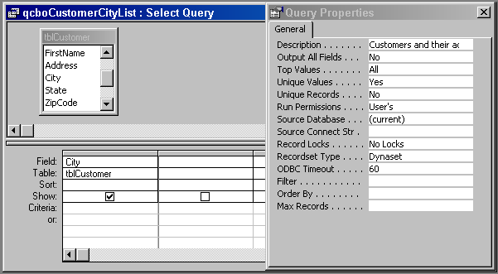

Next, create the fdlgAskForDatesAndCity form.

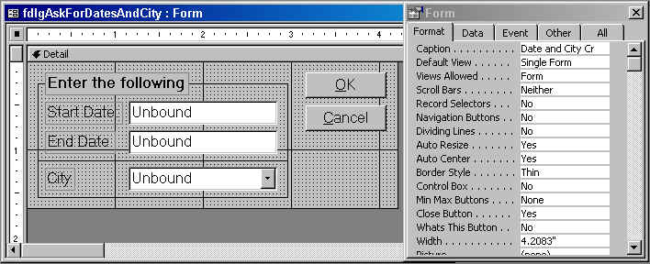

Note the form properties in the Property Sheet. If you set your form’s properties in the same manner, your form will look like a real dialog box.
Now, click the "Other" tab on the Property Sheet. You’re going to assign names to each of the controls on the form using the "Name" property located on this particular tab. Click on the first Text Box control; and enter "txtStartDate" in the Name property. Using the same technique, assign the following names to the remaining controls on the form:

Second textbox: | txtEndDate
Combo box: | cboCity
First command button: | cmdOK
Second command button: | cmdCancel

Once you’ve named all the controls, the final step in creating this form is to write the appropriate Event Procedures for the two command buttons.
Click on the cmdOK button and then click on the Events tab of the Property Sheet. Place your cursor on the On Click event and type a left square bracket. [ You should now see "[Event Procedure]" on the Property Sheet. You should also see a small button with three dots on it just to the right of the On Click event. Press this button to get into the form’s Class Module window; you’ll now see "Private Sub cmdOK_Click()". Just under this line, type in the following:
If IsNull(Me!txtStartDate) Then
MsgBox "You must enter a Start Date."
Me!txtStartDate.SetFocus
ElseIf IsNull(Me!txtEndDate) Then
MsgBox "You must enter an End Date."
Me!txtEndDate.SetFocus
ElseIf IsNull(Me!cboCity) Then
MsgBox "You must select a city."
Me!cboCity.SetFocus
Else
DoCmd.OpenQuery "qryCustomerOrders"
DoCmd.Close acForm, Me.Name
End If
The first part of this procedure ensures that the user entered a start date, a stop date, and selected a city from the combo box. If any of these values are missing, the code will place the cursor in the appropriate control. Once the dates have been entered and a city selected, the code will run the "qryCustomerOrders" query and close the dialog box. (You’ll create this query in just a moment.)
You can now save the procedure and exit the module window. From the menu, select "Debug / Compile Loaded Modules" and then "File / Close". Close and save the form as "fdlgAskForDatesAndCity". The final step is to create the qryCustomerOrders" query.
Create a new query based on both the tblOrder and tblCustomers tables. Use the following fields for the query:
Customer: [LastName] & ", " & [FirstName] (This is a calculated field.)
OrderID
OrderDate
Phone
City
Next, place the following criteria under these fields:
OrderDate: Between [Forms]![fdlgAskForDatesAndCity]![txtStartDate] And [Forms]![fdlgAskForDatesAndCity]![txtEndDate]
City: [Forms]![fdlgAskForDatesAndCity]![cboCity]
You’ll note, no doubt, that both of the criteria are referencing specific controls on the dialog box form. It is because of these references that we were careful to name the controls on the form. If you like, you can sort the query by Customer and OrderDate. Close and save the query as "qryCustomerOrders".

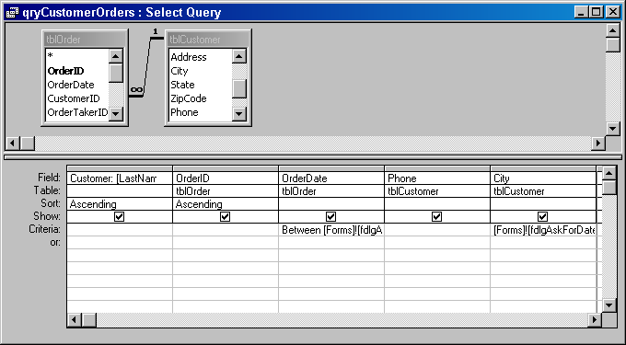

Now for the fun part. Open the fdlgAskForDatesAndCity form; it should look like this (sort of):

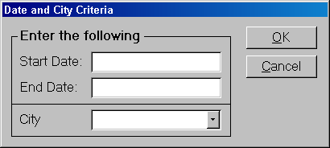

Enter a date range, select a city, and press "OK". You should see your query – with the appropriate data – and the dialog form should be closed. Voila! You now have information based on user input.
You can use this technique to print reports based on user input as well. There are only two extra things you have to do:
- Base the report on the query that references the dialog box form. In our example, you would base a report on the qryCustomerOrders query.
- Change one line in the cmdOK button’s On Click Event Procedure. Change DoCmd.OpenQuery "qryCustomerOrders"
to DoCmd.OpenReport "CustomerOrders", acPreview
That’s all there is to it.

